TASK 1
API testing task — created pytest tests with fixtures in conftest.py. The tests verify that user ID 3 has 10 posts and that GCP/AWS bucket data is not empty for a specific date.
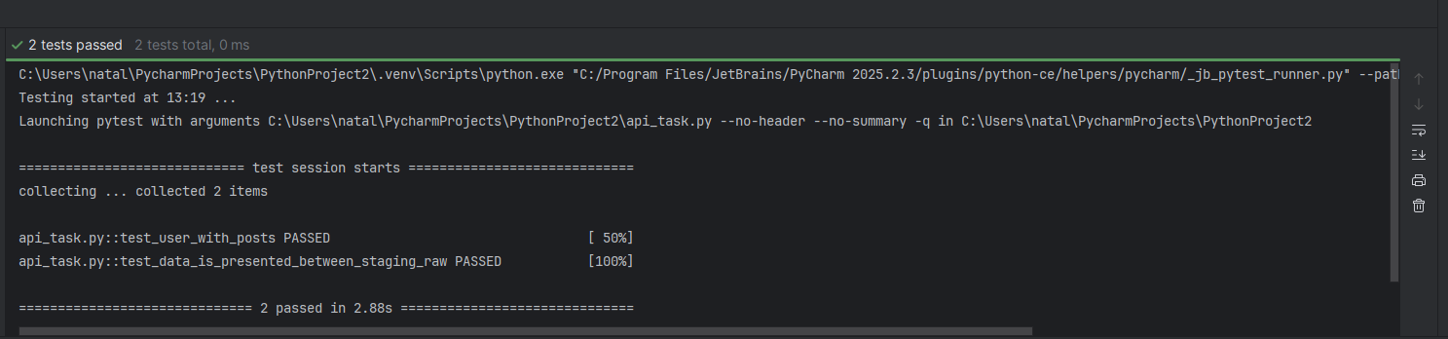

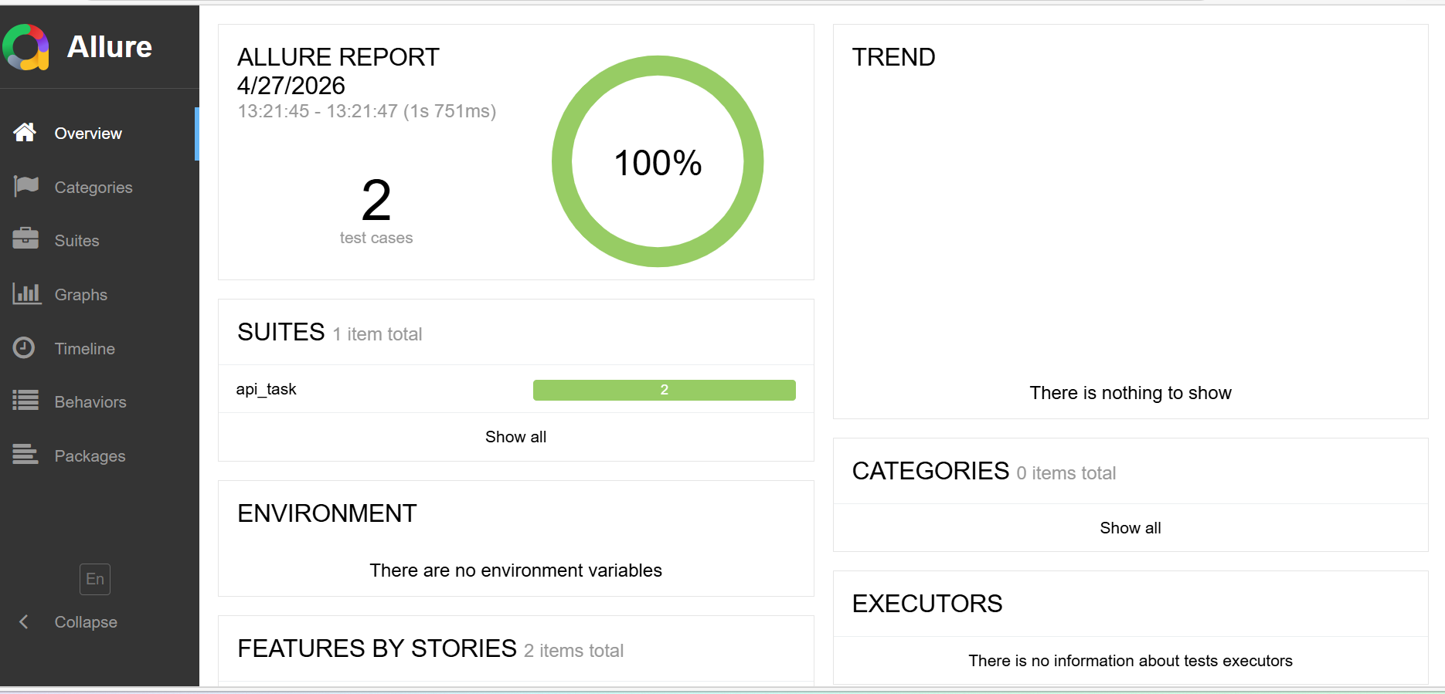
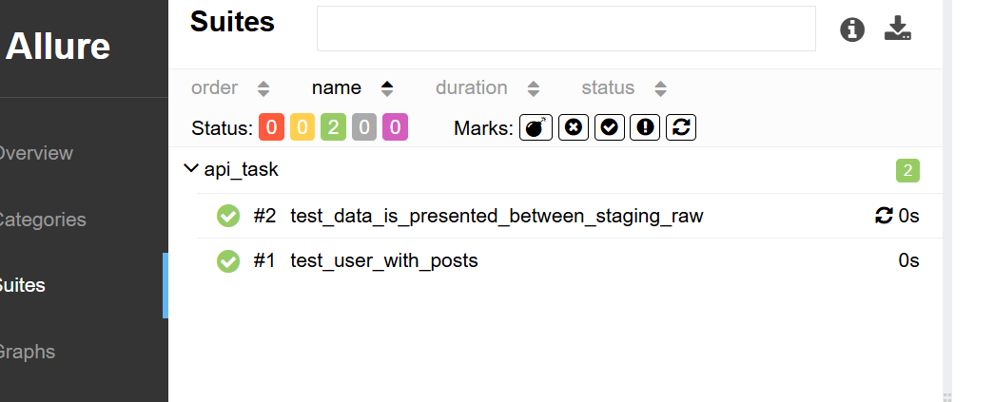

Task 2
Browser automation task — created a Selenium script that opens Google in Chrome and Firefox and prints the page title. Chrome uses the automatic driver approach, while Firefox uses a manually provided driver path.

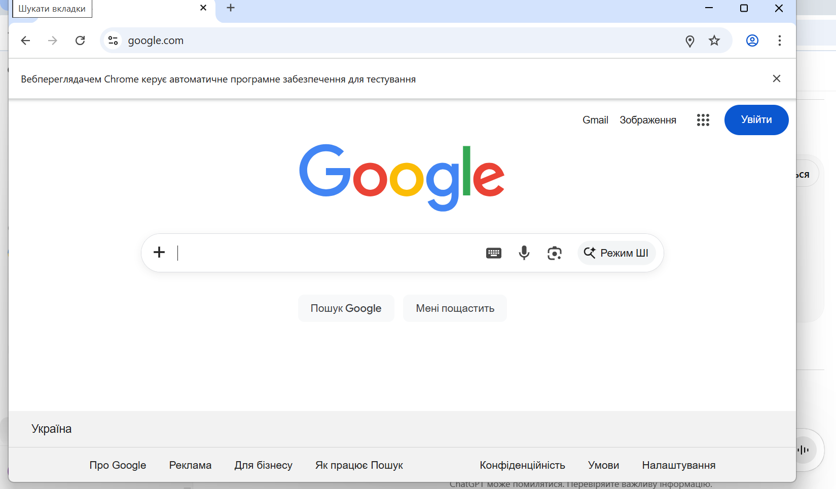
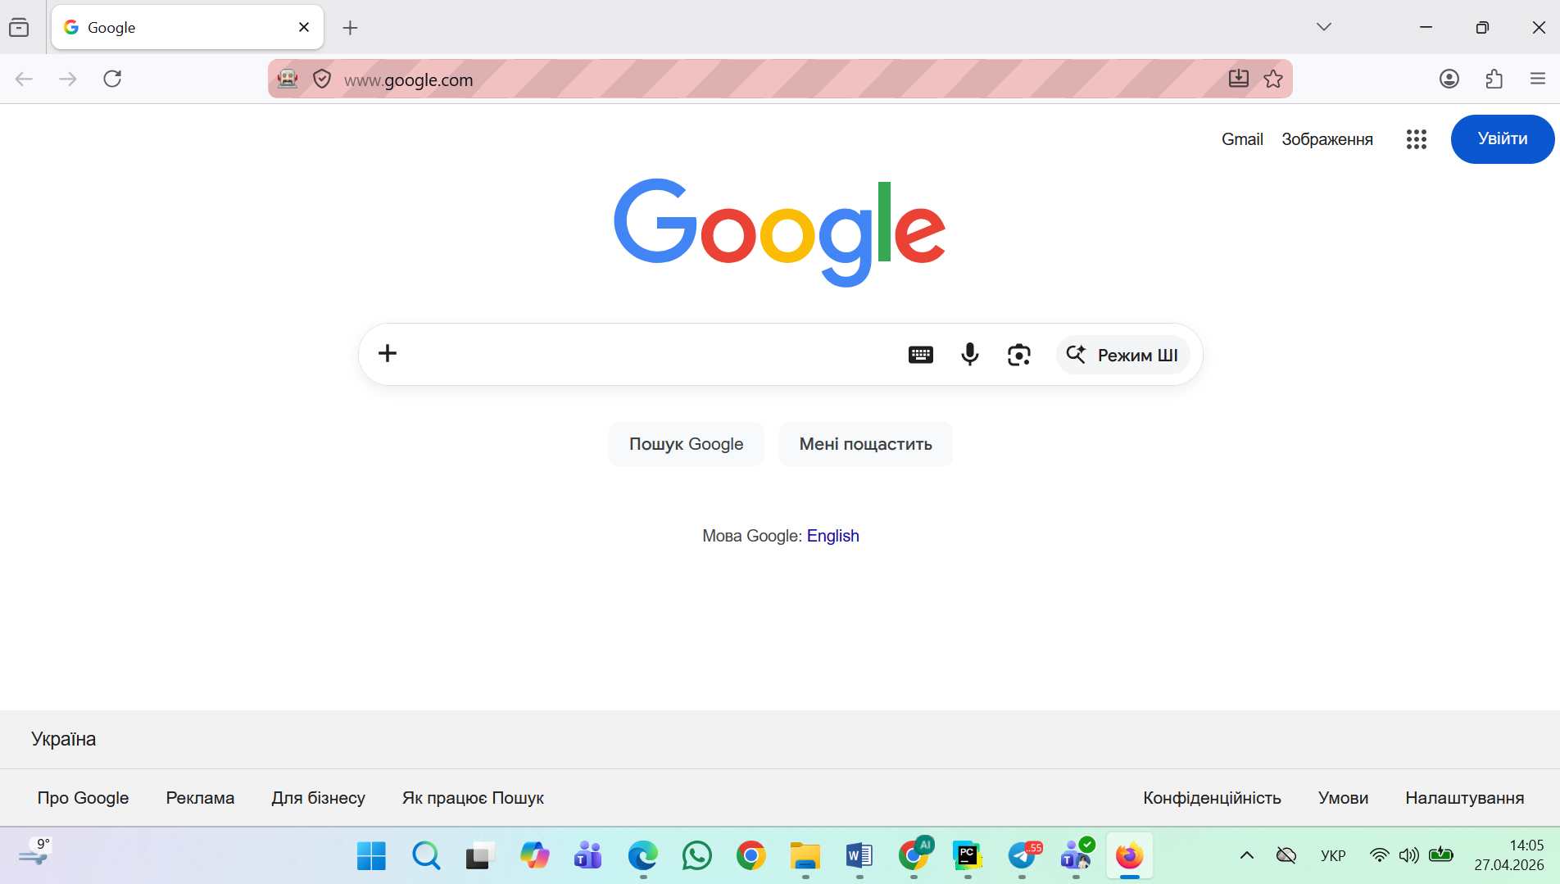
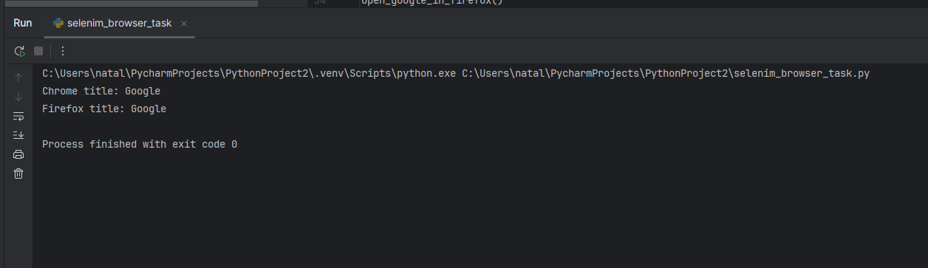
I removed the hardcoded browser path initially, but Selenium could not detect Firefox automatically in my local environment, causing a SessionNotCreatedException. I restored binary_location with a comment explaining why it is required locally.

Task 3
Locators task — prepared Selenium locators for elements from the screenshots, including ID, class name, name, CSS selector, XPath, and relative locators. I also added simple actions such as typing text, clicking, and mouse hover.
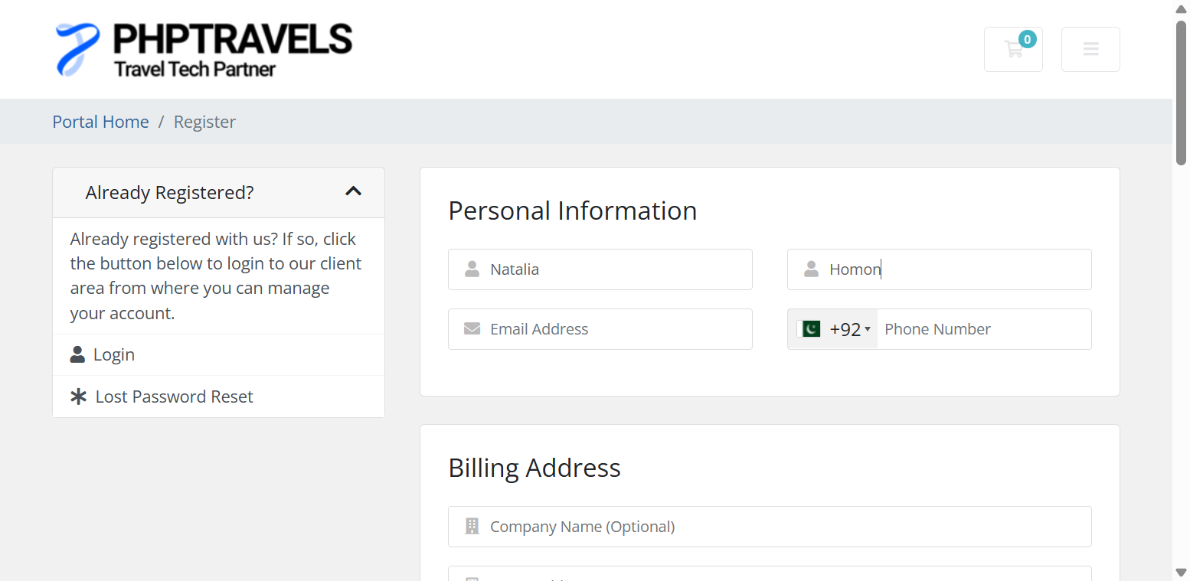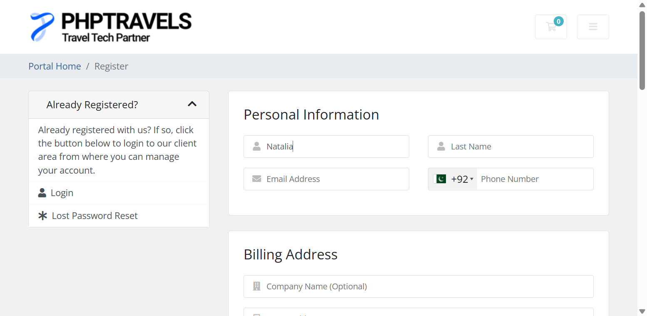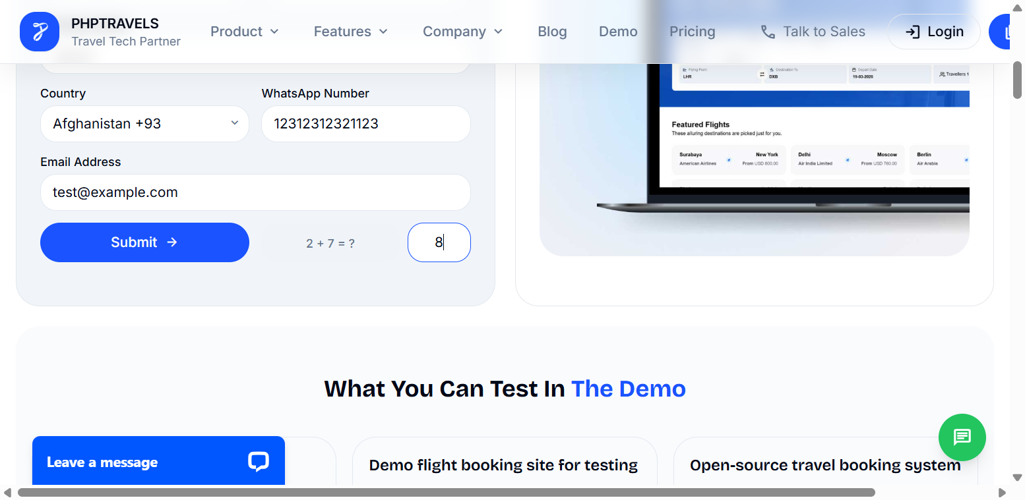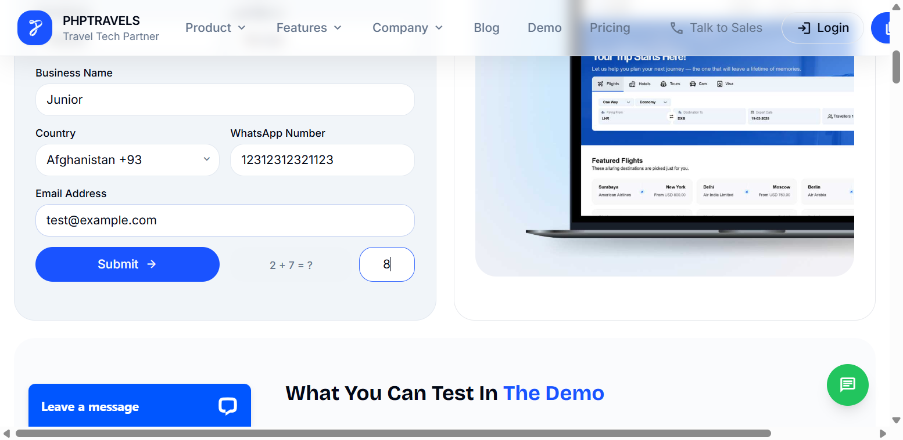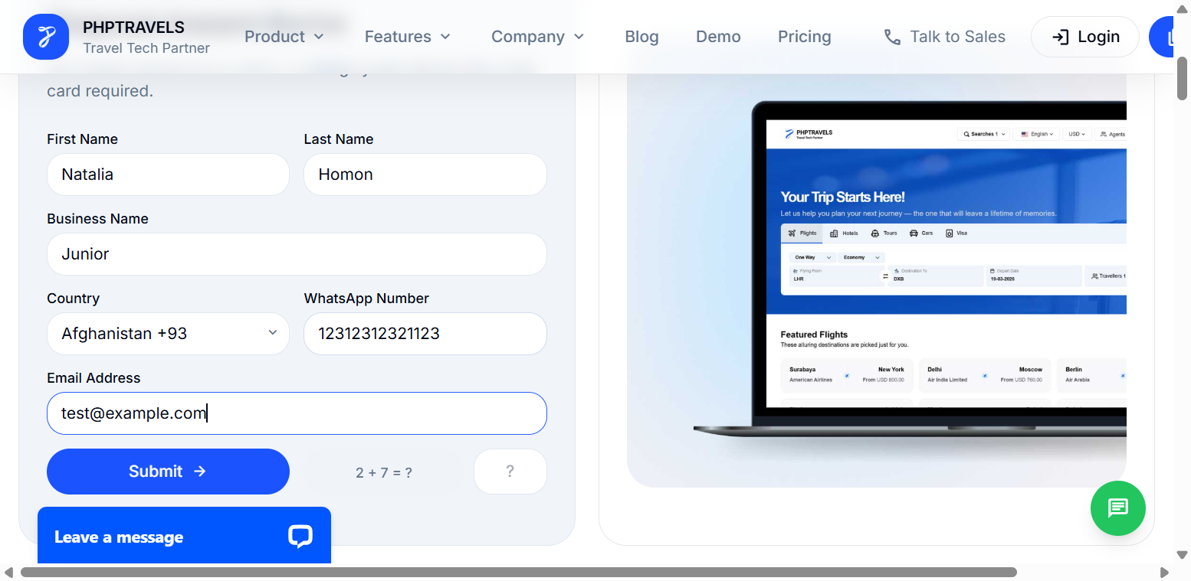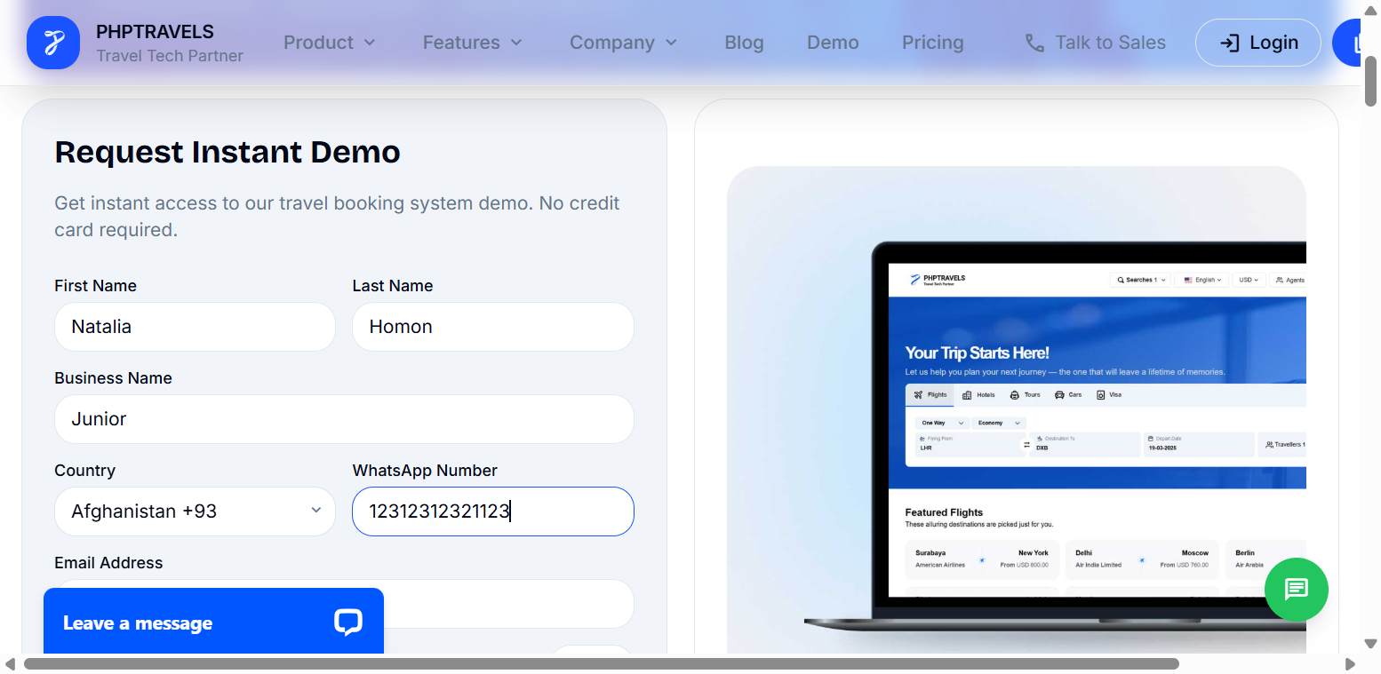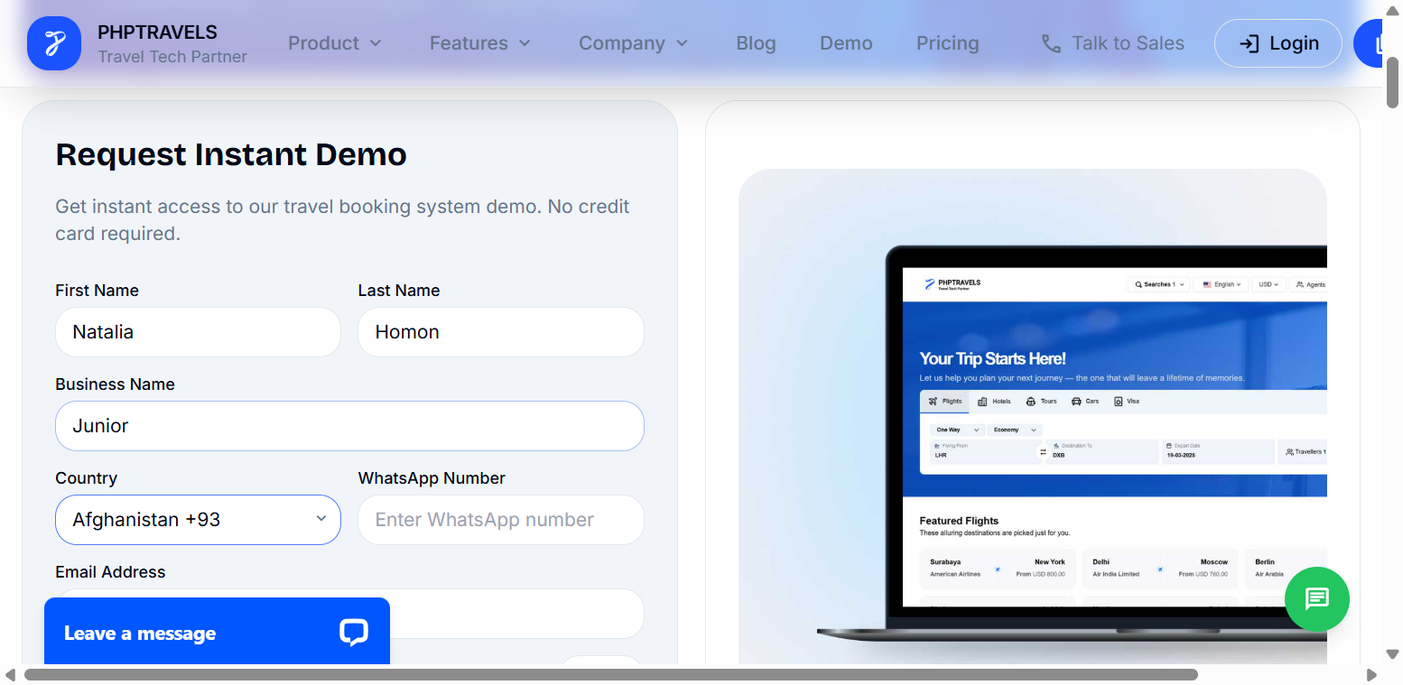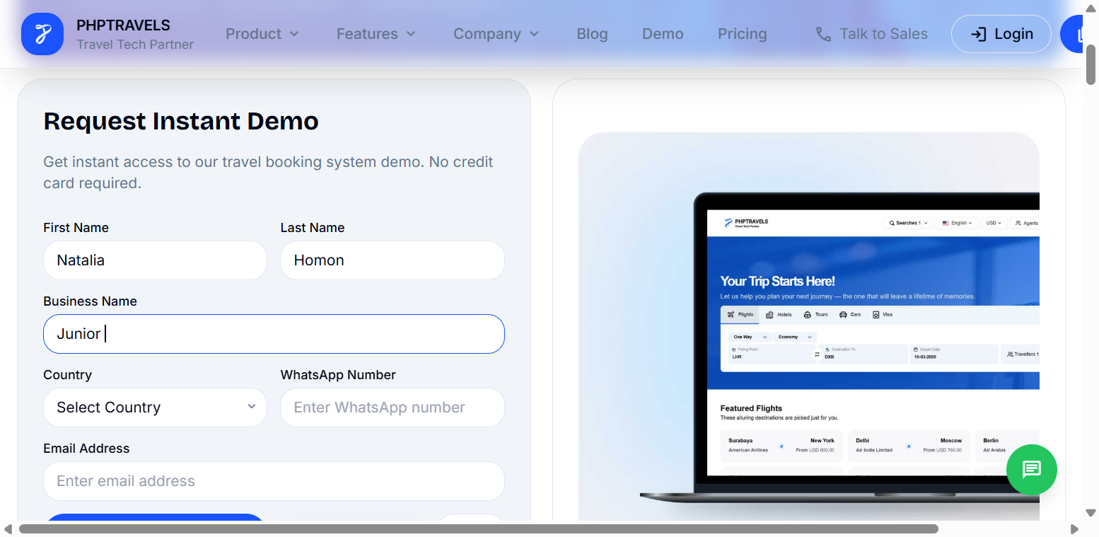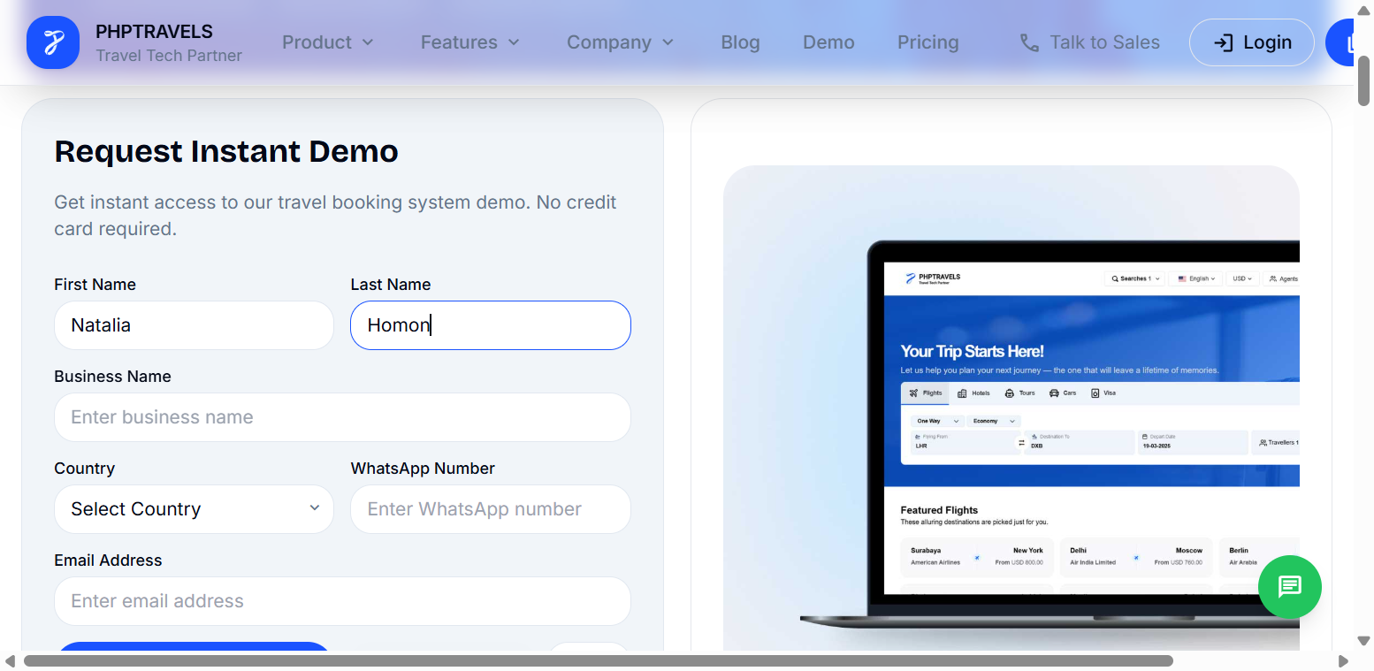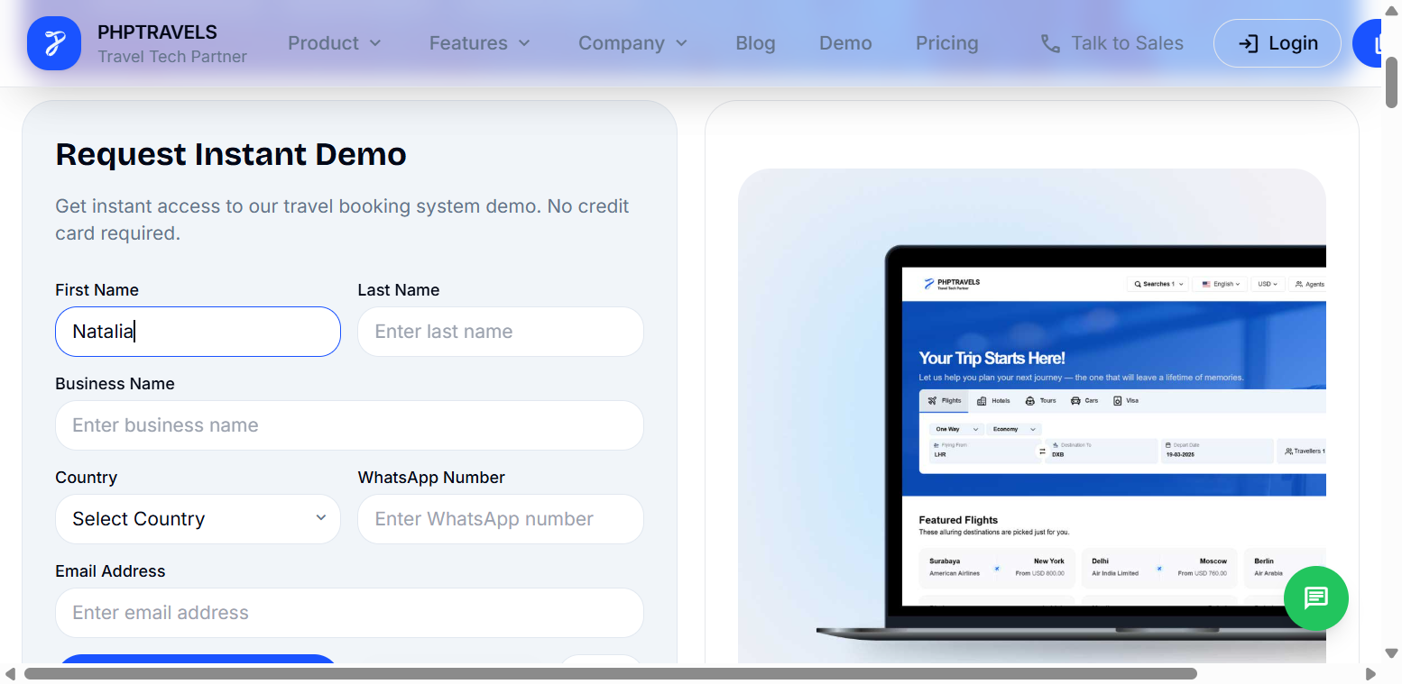
Task 4
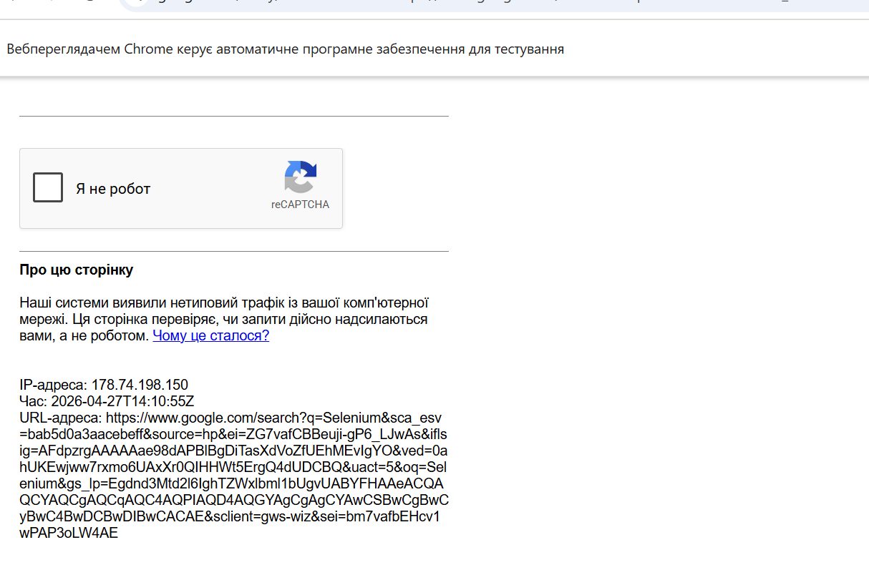
During the execution of the automated test scenario on Google, a CAPTCHA verification page appeared after submitting the search query.
This behavior is caused by Google's anti-bot protection mechanisms, which detect automated traffic generated by tools such as Selenium.
- The CAPTCHA blocks further automated interaction with the search results.
- The test cannot proceed to open the first result link.
- This leads to a failure or interruption of the test execution.
Google identifies the automated browser session (WebDriver) as non-human activity and triggers CAPTCHA to prevent scraping or automated usage.

